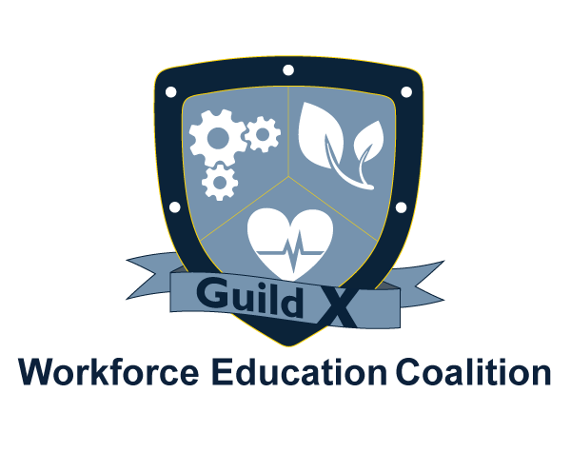

Agenda
Manufacturing Guild X

ADVISORY BOARDS

May 9, 2018

I. Welcome Marybeth Jacobsen

II. Introductions

III. Business Spotlight Vic Anselmo Applied Powdercoat

III. Goal: Advisory Boards

Ventura College Mfg Technology Curriculum:

- Machinist John Clark
- Industrial Technology Maintenance Lead Instructor, Ventura College
Technicians

IV. Announcements (10 min.)
www.WorkforceEC.org • 805-218-2127 • info@WorkforceEC.

Next meeting: June 13, 2018, 8:00 – 9:30 a.m., Pharos Center/VCCF 4001 Mission Oaks Blvd, Camarillo

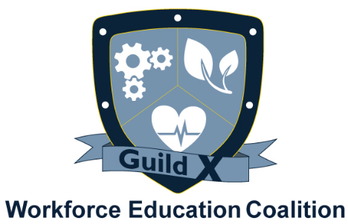

Minutes
Manufacturing Guild X: ADVISORY BOARDS
April 11, 2018
4001 Mission Oaks Blvd., Camarillo, CA

Present:

- Meeting was called to order by Marybeth Jacobsen at 8:04 A.M.

- Meeting Review

Marybeth Jacobsen invited Guild members to sign the WEC’s letter in support of AB 1743. This legislation will allow current CTE funding to continue in contrast to the Governor’s proposal, which will fund K-12 CTE through the community college district. The letter will be submitted on April 13th to the Assembly Finance Committee.

Jacobsen announced the Governor’s proposal for a 115th community college which will be the first fully online community college in California. Industry partners expressed a general dislike for teaching hands on skills on line. Guild members agreed it could be a great supplement to hands-on, learning for general education and theory.

John Clark provided an overview of Ventura College’s machinist program. Guild members pointed out ways to overlap the machinist program with other manufacturing-related curriculum and how they want individuals trained/qualified. Many questions were asked, raising the need to continue the conversation at the next meeting. Clark asked industry partners to complete and share a brief survey of skills needed at various employment levels to better understand how to shape curriculum.

- Announcements

- Meeting time discussion – many Guild members expressed an interest in meeting during the evening, after work. After the discussion about Ventura College’s machinist program the Guild will try meeting in an evening.

- The annual Engineering and Energy Entrée to Employment is coming up. All Guild members in these fields are invited to attend this event.
  - April 25th from 6-8 pm at CSU Channel Islands

  - Contact Mairelise Robinson at M.Robinson@WorkforceEC.org to register or for more information

- Peter Zierhut is working with local representatives to train veterans to be machinists. Guild members are invited to participate in designing the program. Contact Joyce Wallach for more information.
  - Joyce Wallach: Joyce.wallach@gmail.com

- Eleven CNC students graduated from the College of the Canyons with eighteen certificates collectively. Nine have been hired so far and there will be another graduation on September 21st. Guild members are invited to attend the graduation on the 21st, which will be followed immediately by a hiring fair.

- Manufacturing Guild X Chair
  - The Guild needs a new Manufacturing Guild Chair. Responsibilities include: Moderating Manufacturing Guild X meetings and attending occasional executive committee meetings to help create the meeting agendas.
  - If you are interested or would like to nominate someone, please email Marybeth Jacobsen at M.Jacobsen@WorkforceEC.org

- All Guild materials, agendas, minutes, and WEC events can be found on the WEC website. An event calendar can be reached from the home page. Guild agendas will be posted on the calendar.
  - WEC Calendar: https://www.workforceec.org/calendar-1/
  - WEC Guild X: https://www.workforceec.org/guild-x

- Action Steps

Programs Complete:
- The restructure the Manufacturing Guild to be more action driven

Programs in Design:
- VCCCD Career Education Committee – Guild sets agenda item for bi-monthly committee meeting

- Next Meeting: May 9, 2018, 8:00 a.m. at Pharos Center for Innovation

Meeting was adjourned at 9:31 A.M

Recorded by:
Mairelise Robinson
Director of Operations

